

**PRESENTATIONS**

**Room 1-430**

**Global’s Meteorologist: Jesse Beyer**12:00PM

**Dr. Jensen**1:00PM

**Dr. Gelmini**1:45PM

**Mr. Michael Ng**2:30PM

**Grand Finale!**3:15PM

**Room 1-440**

**Brain Awareness Movement**   
12:20PM

**Dr. Loppnow: Keeping your Curiosity!**  
1:20PM

**Let’s Talk Science: Breaking Bonds!**  
2:20PM, 3:20PM

**Room M-137**

**Aerial Robotics Group**  
11:30AM, 1:00PM, 2:30PM

**Room M-141**

**Ecocar**  
12:20PM, 1:30PM

**SCIENCE FUNDAMENTALS**

Science FUNdamentals is a charity organization and student group at the University of Alberta which is dedicated to enhancing elementary education by sparking interest and curiosity about science in the young minds of our community. Our group was founded in 2003 and we currently have over 140 volunteers that regularly visit elementary classrooms across Edmonton to present interactive science demonstrations. Science FUNday is our free annual science exhibition.





**FUN-filled day of science exploration!**

**Saturday, March 12th 2016**

**10AM to 4PM**

**Centennial Centre for Interdisciplinary Science**

**THANK YOU for attending our event.   
We look forward to seeing you next year!**

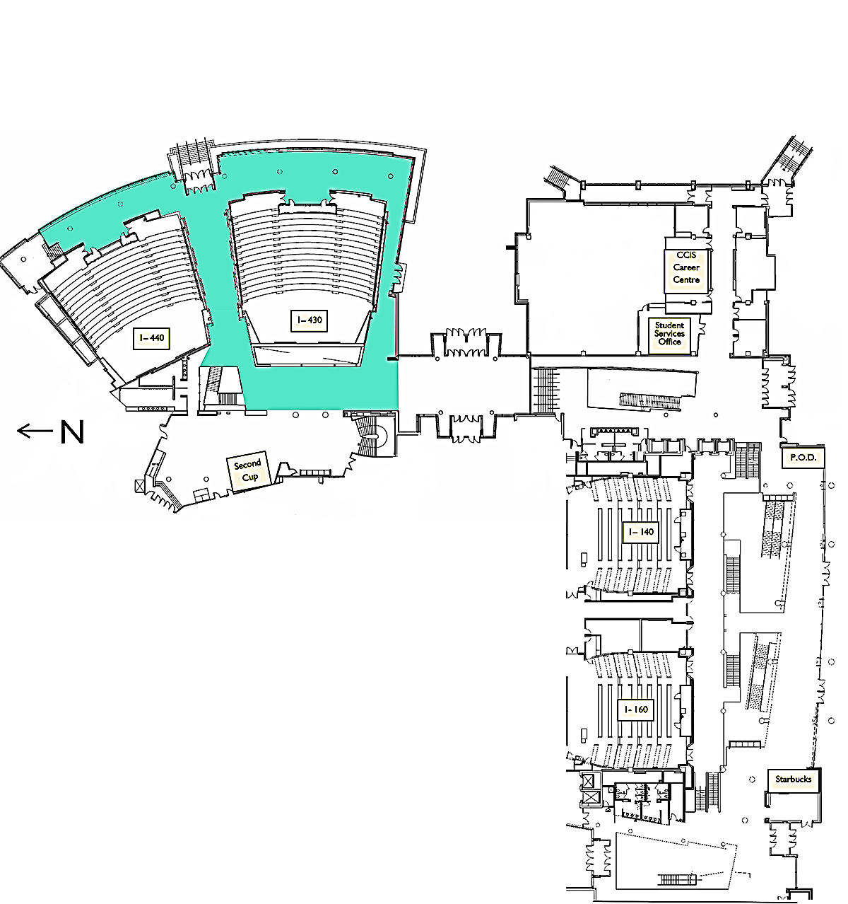

QUAD 🡪

Washrooms 🡪

First Aid 🡪  
(follow red signs)

Rest Area 🡪   
(follow blue signs)

Health

Physics

Biology

Chemistry

Glow Room

Front Desk

Tours

Food

Entrance

Entrance

Entrance

Stairs to go Down   
 Edmonton Valley Zoo  
 AlbertaSat Cube Satellites   
 WISEST  
 LED Bookmarks   
 Room M-137  
 Room M-141

Room 1-440

Room 1-430

Washrooms

Enter

Enter

Liquid Nitrogen Ice Cream

Strawberry DNA

LED Bookmarks

Scientists Walk of Fame

Don’t forget to get a stamp for these activities!

Scientists Walk of Fame